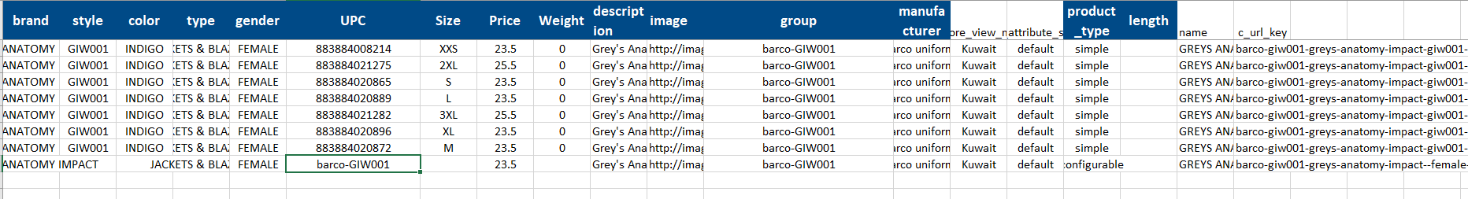

Import Settings:

Remove all images: ON

Product url pattern: [product_name]_[product_sku]

Import Behavior

Only Add

